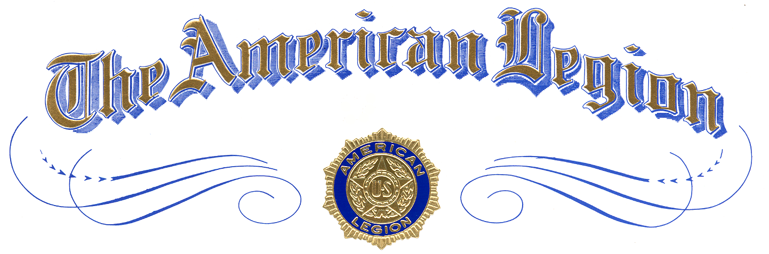

Winner of

xx Division Oratorical

Winner Name
of
School Name

is awarded this certificate of Achievement
and a $0,000 Scholarship
in

The American Legion
National High School Oratorical Contest

Presented by
Commander, The American Legion Division xx
at City, Texas
Month Day, Year

Attest:

